**Főoldal:**

“Bevezető szövegdoboz”:

What is Neurodivergency?

“1.oldal essszé része(bevezetés a ) Lórem xd”:

“Neurodivergency” is an umbrella term referring to a wide variety of learning and developmental disorders. Two of the most well-known ones are Autism Spectrum Disorder and Attention Deficit Hyperactivity Disorder also known as ASD and ADHD, however the term also includes Tourette’s Syndrome, Dyslexia, Dyspraxia, Dyscalculia, Dysgaphia, Meares-Irlen Syndrome, Hyperlexia and Synaesthesia. In comparison to how much of the population is affected, since between 30% and 40% of the total population is thought to be neurodiverse, there is astonishingly little cultural and social awareness of how they experience the world, how they are generally treated by society and how to accommodate non neurotypical people. This in my personal experience of listening to people *(I am no psychologist)* with any of the conditions that the term refers to, is that they were in some way shape or form mistreated by society at some point in their life.

“Táblázat”:

|  |  |  |
| --- | --- | --- |
| Disorder: | Pros: | Cons |
| Autism | Good memory  Attention to details  Deep focus  Great pattern recognition  Analiticalness  Integrity | Difficulty with small talk  Extremely literal  Sensory issues  Facing social rejection/bullying  Trouble with non-verbal communication |
| ADHD | Creativity  Hyperfocus  Abundant energy  Spontaneity  Versatile skillsets | Forgetfulness  Lack of understanding of time  Being easily distracted  Difficulty maintaining conversations  Racing and parallel thoughts  Impulsiveness  Low executive function |
| Dyslexia | Great imaginativeness  Strong Visual Memory  Excellent 3D perception and reasoning | Difficulty with reading  Difficulty whit language processing |
| Tourette | (couldn’t find any :( ) | Tics (sudden twitches, movements, or sounds that are uncontrollable) |

Ürlap:  
<https://docs.google.com/forms/d/e/1FAIpQLScxLWhKBQMxodiezmj8jNphEMyWJzpBWI4GO1b_HrRNr_q5_Q/viewform?vc=0&c=0&w=1&flr=0>

**ASD:**

“ASD cím sor”:

Autism Spectrum Disorder:

“Leírás az Autizmusról”:

Autism is a neurodevelopmental disorder characterized by difficulties with social interaction and communication, and by restricted and repetitive behavior. Parents often notice signs during the first three years of their child's life. These signs often develop gradually, though some autistic children experience regression in their communication and social skills after reaching developmental milestones at a normal pace.

“ASD kép”:



“releváns video”:



“resource-ok és linkek a témával kapcsolatban”:

<https://www.youtube.com/watch?v=y4vurv9usYA>

<https://embrace-autism.com/raads-r/>

<https://en.wikipedia.org/wiki/Autism>

<https://speechblubs.com/blog/autism-spectrum-disorder-all-in-one-guide/>

<https://www.tiktok.com/tag/autistiktok>

<https://www.youtube.com/c/ComingHometoAutism>

**ADHD:**

“ADHD cím sor”:

Attention Deficit Hyperactivity Disorder:

“Leírás az ADHD-ról”:

Attention deficit hyperactivity disorder (ADHD) is a neurodevelopmental disorder characterized by inattention, hyperactivity, and impulsivity, which are pervasive, impairing, and otherwise age inappropriate. Some individuals with ADHD also display difficulty regulating emotions, or problems with executive function. For a diagnosis, the symptoms have to be present for more than six months, and cause problems in at least two settings (such as school, home, work, or recreational activities). In children, problems paying attention may result in poor school performance. Additionally, it is associated with other mental disorders and substance use disorders. Although it causes impairment, particularly in modern society, many people with ADHD have sustained attention for tasks they find interesting or rewarding, known as hyperfocus.

“ADHD kép”:

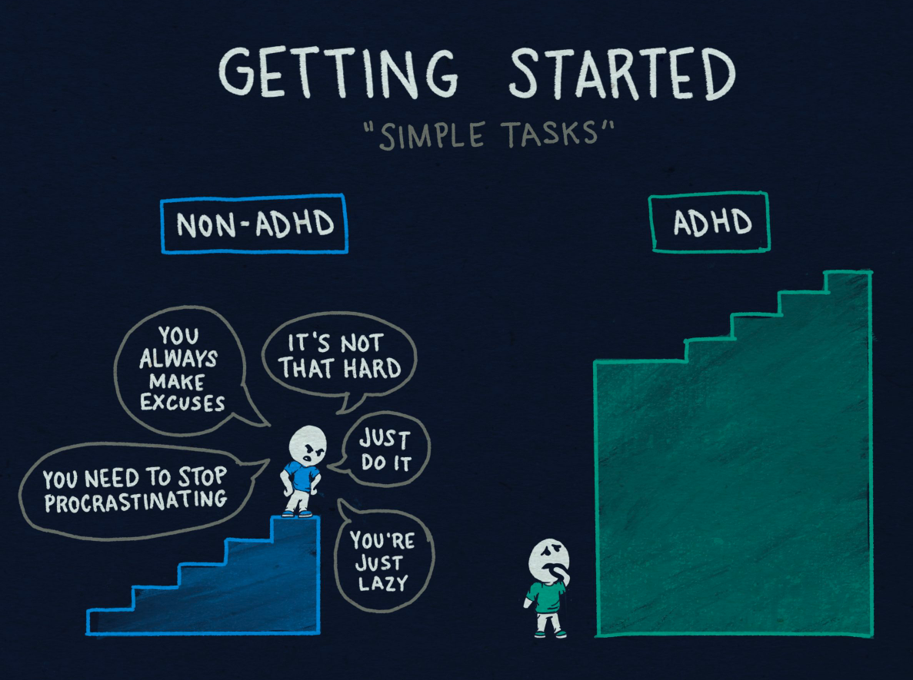

“releváns video”:



“resource-ok és linkek a témával kapcsolatban”:

<https://www.adhddd.com/>

<https://www.youtube.com/c/HowtoADHD>

<https://www.webmd.com/add-adhd/childhood-adhd/adhd-resources/>

<https://chadd.org/>

<https://open.spotify.com/episode/2rOBrfKwFLz0LJJ7bnI724?si=1a9e4783295c4413>

<https://en.wikipedia.org/wiki/Attention_deficit_hyperactivity_disorder>

**Dyslexia:**

“Dyslexia cím sor”:

Dyslexia:

“Leírás az Dyslexiáról”:

Dyslexia, also known as reading disorder, is a disorder characterized by reading below the expected level for their age. Different people are affected to different degrees. Problems may include difficulties in spelling words, reading quickly, writing words, "sounding out" words in the head, pronouncing words when reading aloud and understanding what one reads Often these difficulties are first noticed at school.When someone who previously could read loses their ability, it is known as alexia. The difficulties are involuntary and people with this disorder have a normal desire to learn. People with dyslexia have higher rates of attention deficit hyperactivity disorder (ADHD), developmental language disorders, and difficulties with numbers.

“Dyslexia kép”:



“releváns video”:



“resource-ok és linkek a témával kapcsolatban”:

<https://en.wikipedia.org/wiki/Dyslexia>

<https://www.youtube.com/watch?v=QrF6m1mRsCQ>

<https://www.dyslexiefont.com/>

<https://dyslexiaresource.org/>

**Turrets:**

“Turrets cím sor”:

Tourette Syndrome:

“Leírás az Turretsről”:

Tourette syndrome or Tourette's syndrome (abbreviated as TS or Tourette's) is a common neurodevelopmental disorder that begins in childhood or adolescence. It is characterized by multiple movement (motor) tics and at least one vocal (phonic) tic. Common tics are blinking, coughing, throat clearing, sniffing, and facial movements. These are typically preceded by an unwanted urge or sensation in the affected muscles known as a premonitory urge, can sometimes be suppressed temporarily, and characteristically change in location, strength, and frequency. Tourette's is at the more severe end of a spectrum of tic disorders. The tics often go unnoticed by casual observers.

“Turrets kép”:

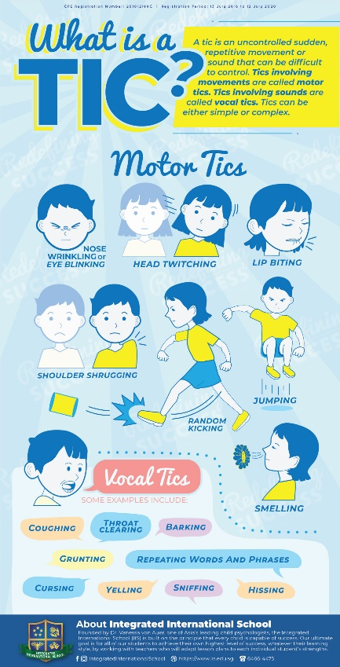

“releváns video”:



“resource-ok és linkek a témával kapcsolatban”:

<https://www.cdc.gov/ncbddd/tourette/facts.html>

<https://en.wikipedia.org/wiki/Tourette_syndrome>

<https://tourette.org/about-tourette/overview/what-is-tourette/>

<https://www.twitch.tv/sweet_anita>